 | MECHANICAL
 | AZEI-002-XXXXXX-XXX-PA | AZEI-002-XXXXXX-XXX-PB | AZEI-002-XXXXXX-XXX-PC
 | 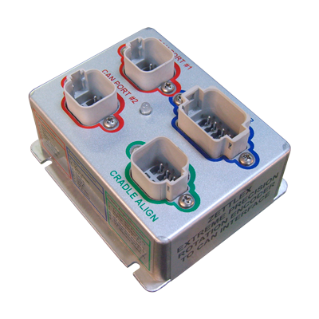 | 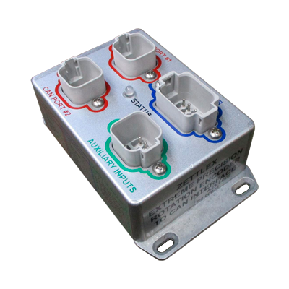 | 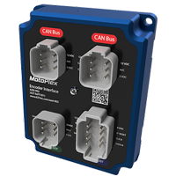
Length | 4.35" (110 mm) | 5.5" (140 mm) | 4.5" (115 mm)
Height | 2.2" (56 mm) | 2.2" (56 mm) | 1.7" (42 mm)
Depth | 3.75" (95 mm) | 3.2" (82 mm) | 3.5" (90 mm)
Material | Die-cast Aluminum Alloy | Die-cast Aluminum Alloy | Machined Aluminum
Finishing | Vibra Finished | Vibra Finished | Anodized
Weight | 360 g | 355 g | 400 g
 | ENVIRONMENTAL
Operating Temperature | -40°C to 85°C
Storage Temperature | -50°C to 85°C
Vibration | Level ±3g, 10Hz to 200Hz (random) @ 3.6g(rms)
Shock | 20g, 6mS, half sine profile
Life Cycle | 100 000 hours
EMC Immunity Level | 100V/m, 30MHz to 1GHz, 1KHz 80% sine wave modulation, EN50082-2
EMC Emissions Level | Complies with EN50081-2 (1993), 150kHz to 30MHz, level B
 | ELECTRICAL
Voltage (Supply) | 6.5-38 VDC
Current (Supply) | < 25mA
Over Voltage | Up to 50 VDC for 2 sec
Threshold voltage | 3.2 V+/-5%
Reverse Polarity Protection | YES
Input Resistance | 20 KΩ
 | GENERAL
Supported Technology | MOTOPLEX
Protocols | CAN J1939
Baud Rate | 250 Kbit/s

