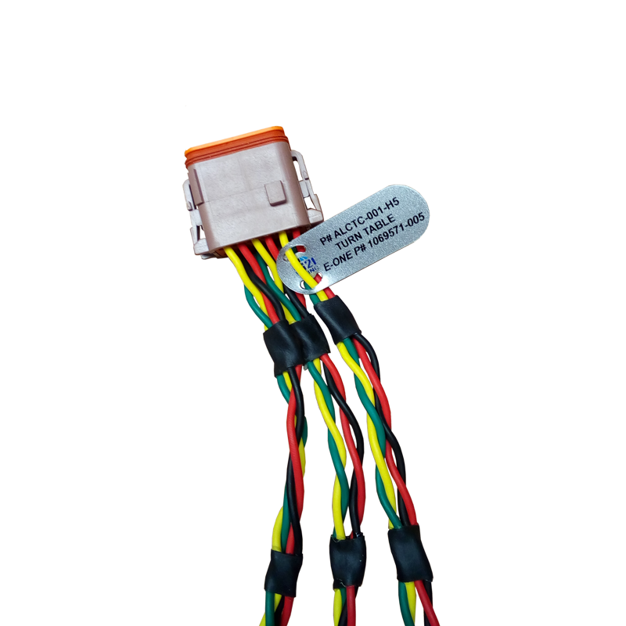

**P# ALCTC-001-H5**

***TURN TABLE E-ONE P# 1069571-005***